1. Vd 1

Springbootthymeleafdemo => default config for thymeLeaf

Put html file in template folder

*5. vd5: thymeLeaf Expression syntax – thymeleafexpressionsyntax*

*src/main/resources/templates/simpleExpression.html*

* During runtime replace all content of <p> tag by value of th:xxx
* If open static html file => stay the same
* Put java object as attribute of Model in controller 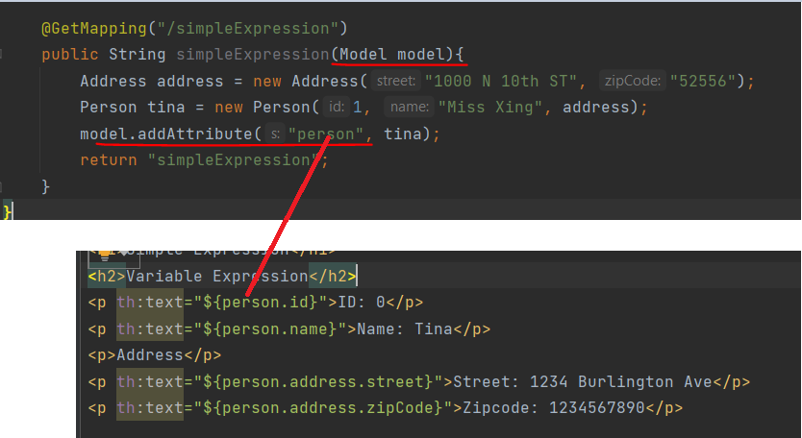
* 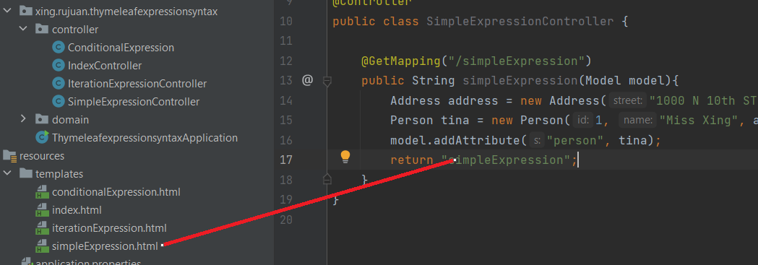

*6. Selection Variable Expression - thymeleafexpressionsyntax (same 5)*

*src/main/resources/templates/simpleExpression.html*

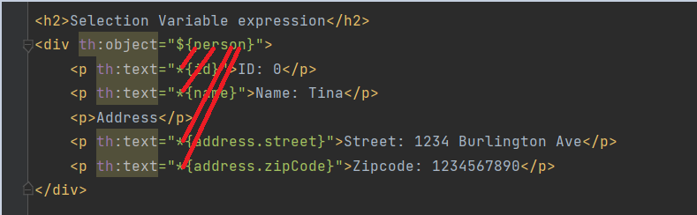

*7.* *Message Variable - thymeleafexpressionsyntax (same 5)*

*src/main/resources/templates/simpleExpression.html*

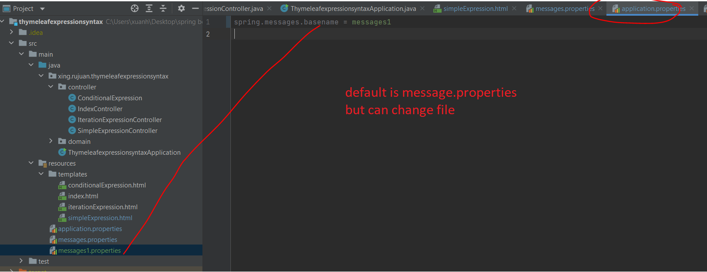

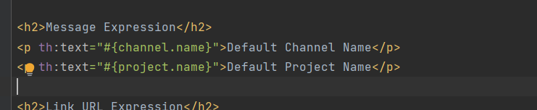

*8.* *Link URL Expression*

*thymeleafexpressionsyntax (same 5)*

*src/main/resources/templates/simpleExpression.html*

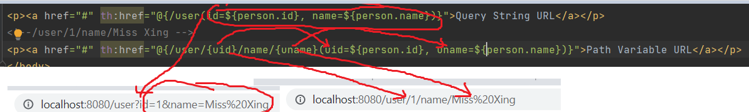

*9. ConditionalExpression.java*

*thymeleafexpressionsyntax (same 5)*

*ConditionalExpression.java*

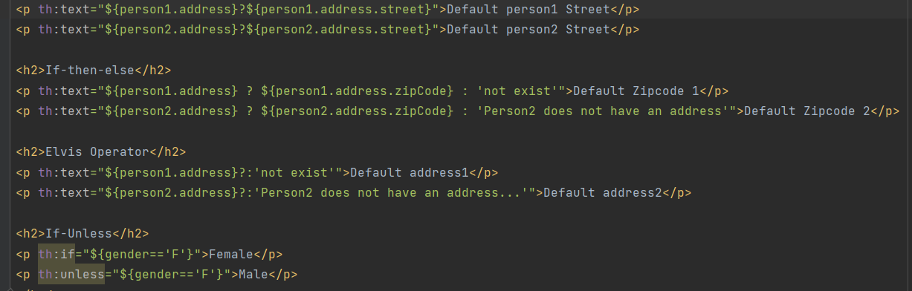

* *If (person1.address exist) => show ${person1.address.street}"*

${person1.address} ? ${person1.address.zipCode} : 'not exist'"

* *If (person1.address exist) => show ${* *person1.address.zipCode } else show: 'not exist'*

${person1.address}?:'not exist'

* *If (person1.address) exist => show itself else show “not exist”*

<p th:if="${gender=='F'}">Female</p>

* *If (gender == F (CONTROLLER)) => show Female (inside <p>))*

*10.* *Iteration Expression in Thymeleaf*

*IterationExpressionController.java*

iteration is variable used to keep track of status of looping sofar: how many item being looped, is the current item the first one or last one

can be used any name

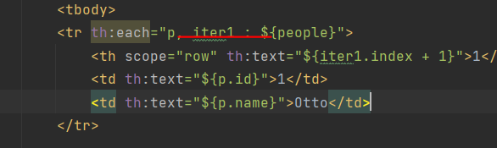

**BAELDUNG**

1. [**https://www.baeldung.com/thymeleaf-in-spring-mvc**](https://www.baeldung.com/thymeleaf-in-spring-mvc)